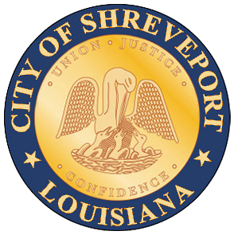 | City of Shreveport  Permit Application for  FEMA Special Flood Hazard Area

Project Title: Click here to enter text.
Address: Click here to enter text.
FEMA Zone: Click here to enter text. (A, AE, AH, AO, etc.)
FEMA Floodway: ☐Yes ☐No
If yes, additional information will be required by City Ordinance/FEMA. Please contact the City’s Floodplain Administrator (Matthew Redmon at 318-673-6000).
Base Flood Elevation: Click here to enter text.
Elevation of top of bottom floor (including basement, crawlspace or enclosure floor): Click here to enter text.

☐No fill will be placed in the regulatory floodway
☐All necessary Federal, State, and local permits have been obtained
☐Compliance with Sections 9 and 10 of the Endangered Species Act (ESA) has been achieved
☐The land and any existing or proposed structures to be removed from the SFHA are or will be reasonably safe from flooding as defined in 44CFR 65.2(c)
☐An Elevation Certificate will be turned into the City of Shreveport, Department of Engineering and Environmental Services prior to issuance of the Certificate of Occupancy

Name of Engineer: Click here to enter text.
Signature: _________________________________________________
Date: Click here to enter a date.

