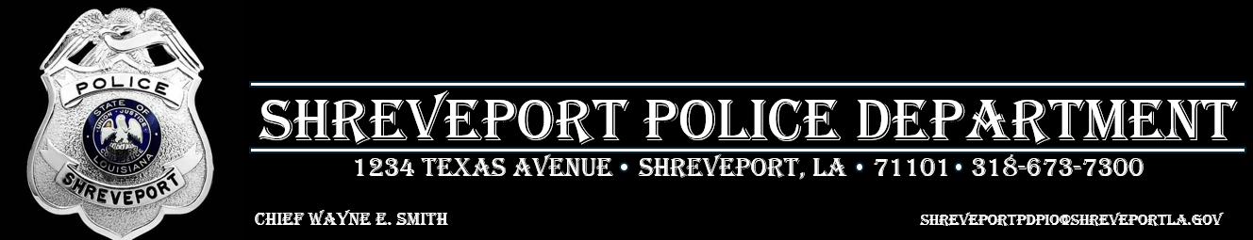
FOR IMMEDIATE RELEASE 3/18/26

Shreveport Police Seek Suspect in Aggravated Assault with a Firearm Investigation
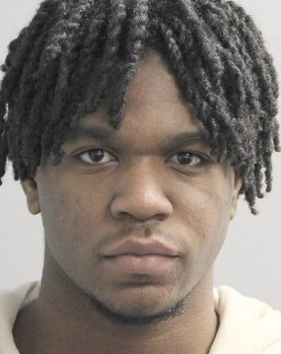
Jacorreyon Graham
On March 1, 2026, officers with the Shreveport Police Department’s Violent Crimes Unit, along with patrol officers, were involved in an investigation stemming from a reported incident involving a firearm.
During an interview related to a separate ongoing case, a victim informed investigators that an individual known as “Baby Shotta” had pointed a firearm at her while she was at a residence in the 600 block of Harrison Street on Sunday, March 1, 2026. The victim reported that the suspect’s actions caused her to fear she would be shot or otherwise harmed.
Detectives with the Violent Crimes Unit conducted follow-up interviews with additional individuals who were present at the time of the incident. Through the course of the investigation, officers were able to identify the suspect as Jacorreyon Graham (09/05/2007).
Based on the information gathered, an arrest warrant has been issued for Graham on the following charge:
- One count of Aggravated Assault with a Firearm (LA R.S. 14:37.4)
At this time, Jacorreyon Graham is considered armed and dangerous.
Anyone with information on his whereabouts is urged to contact the Shreveport Police Department at 318-673-7300 or submit an anonymous tip through Caddo Crime Stoppers at 318-673-7373.
The Shreveport Police Department remains committed to holding individuals accountable for violent offenses and ensuring the safety of our community.

